Performance Review

Name:
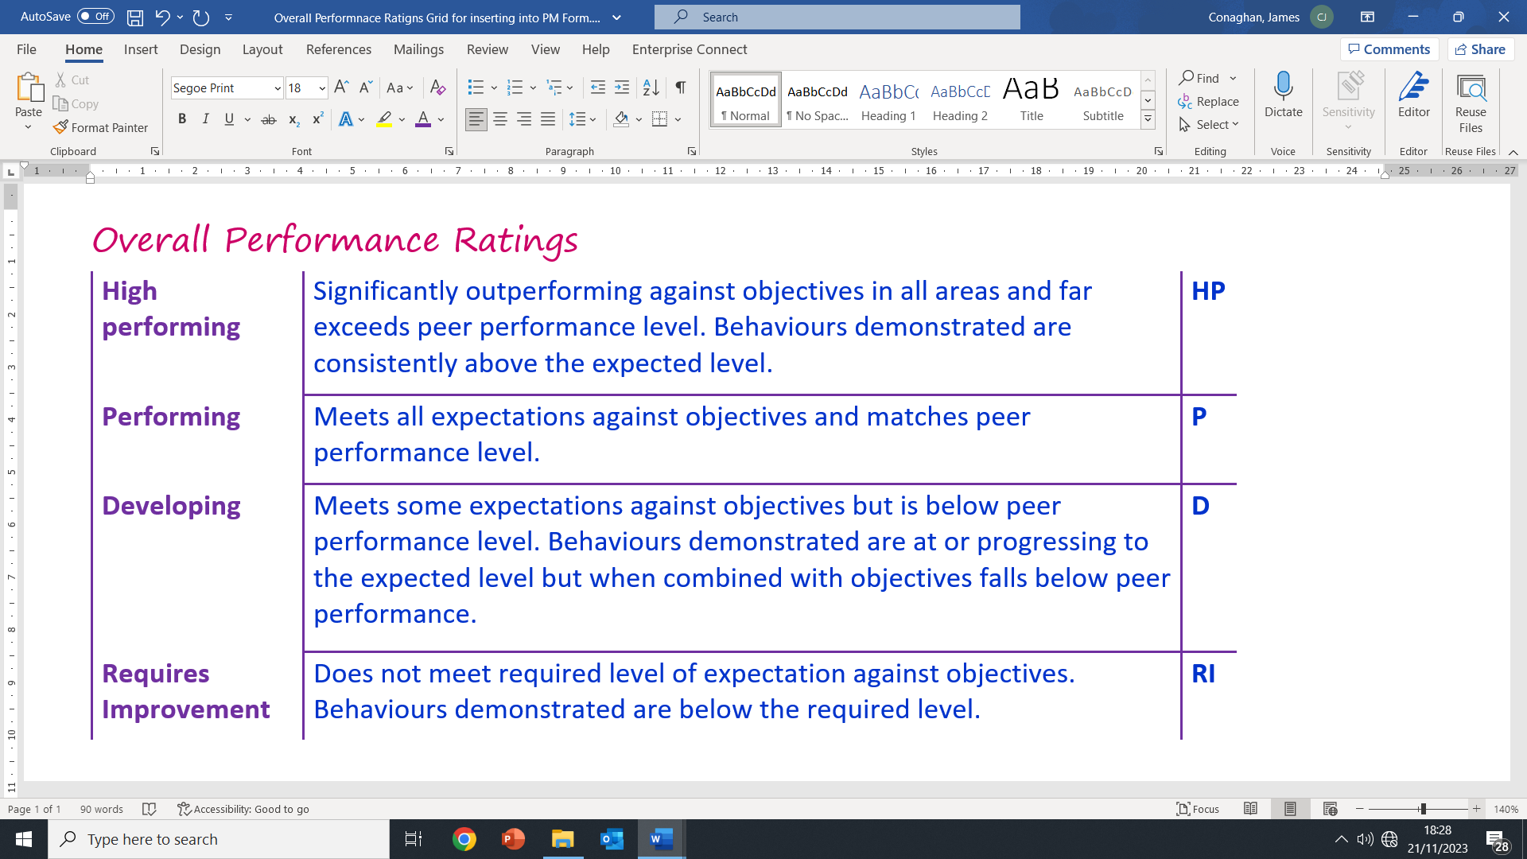
Unit:
SAP:
Effective performance management in Glasgow Life creates an environment that enables everyone to perform to the best of their ability. Our vision is: everyone deserves a great Glasgow life, and Performance Management provides us with the individual direction we need to demonstrate our contribution to achieve this vision.
This document can be used to prepare for your review and document the final discussion points with your supervisor / manager.
Support information can be found in the ‘Guide to Driving High Performance’.

Objectives Review - Provide examples or evidence of how you are currently performing against your objectives. Remember to include any information from the past 12 months.
What objectives need to be achieved? (all objectives need to be SMART) | Half year review (review of what has been achieved against the objectives) | Full year review (review of what has been achieved against the objectives) | Final Rating
Employee signature to agree objectives: Date: Overall rating for objectives
Behaviour Review - Provide examples or evidence of how you are currently performing against your behaviours.
The behaviour clusters – (Behaviour clusters relevant to your role) | Half year review (provide examples of where behaviour has been demonstrated) | Full year review (provide examples of where behaviour has been demonstrated) | Annual Rating
Overall rating for behaviours

Summary of Review
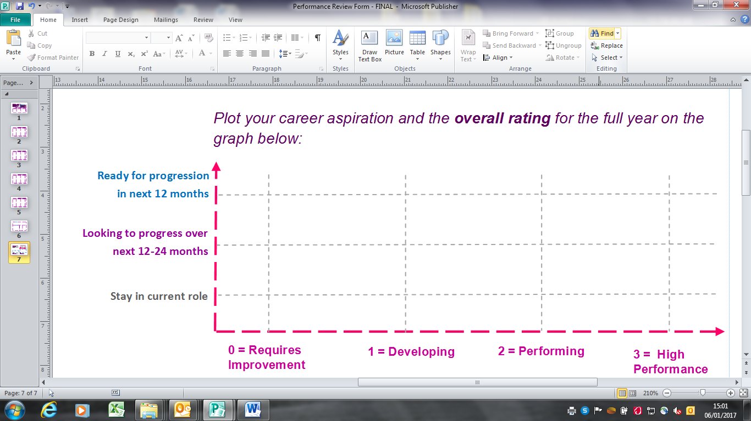
Once your performance against the behaviour clusters and your objectives has been reviewed, agree the overall performance rating with your manager. Overall ratings summary:
Objectives |  |  | Behaviour clusters |  |  | Overall rating
Half Year | Full Year |  | Half Year | Full Year |  | Half Year | Full Year

Employee Career Aspirations: | Full Year - Summary / Comments of Review:
Half Year - Summary / Comments of Review:
Half Year Review Full Year Review
Manager Signature: _________________________________________ Manager Signature: ____________________________________________
Employee Signature: _________________________________________ Employee Signature: ____________________________________________
Date: __________________________ Date: ______________________
Note: Copy to be retained by both the employee and the manager.
Development Plan
Development needs: What are you trying to develop?
Innovation ideas: What ideas do you have on how we can improve our products, services and/or processes that will make a difference to our internal / external customers?

Development actions: What development activities am I specifically going to do? E.g Projects, work-shadowing, coaching, training, GOLD, etc. | Target dates for completion | Review of actions

